|  |  |
| --- | --- |
|  |  |

Undergraduate Project Report

2015/16

**[User behaviour analysis based on Deep Packet Inspection]**

|  |  |
| --- | --- |
| Name: | [Cheng Qian] |
| Programme: | [Telecom] |
| Class: | [2012215104] |
| QM Student No. | [120721267] |
| BUPT Student No. | [2012212860] |
| Project No. | [RN_2860] |

**Date** [**2016/05/16]**

Table of Contents

Abstract 3

Chapter 1: Introduction 5

Chapter 2: Background 6

2.1 User behaviour analysis 6

2.2 Deep Packet Inspection 6

2.2.1 Packet 6

2.2.2 Inspection principle 7

2.2.3 Three main recognition technology 8

2.3 Advantage of using DPI on user behaviour analysis 9

Chapter 3: Design and Implementation 10

3.1 nDPI platform deployment and testing 10

3.1.1 Open source plans selection 10

3.1.2 Deployment in a real network environment 10

3.2 Real-time grasp the Internet packets and analyses the protocol type 11

3.2.1 Execution flow 11

3.2.2 Regular expression summary 16

3.2.3 Chunked packet encoding format in HTTP message and decompression implementation with C 18

3.3 Programming realization of user behaviour analysis system 20

3.3.1 MySQL storage 20

3.3.2 Front-end query system 21

Chapter 4: Results and Discussion 26

Chapter 5: Conclusion and Further Work 27

References 28

Acknowledgement 29

Risk Assessment 30

Environmental Impact Assessment 31

# Abstract

Deep Packet Inspection (DPI) is a software solution that monitors a network’s data stream and identifies protocols and applications, inappropriate URLs, instructions attempts and malware by looking deep into data packets. DPI provides important security and translation functions by inspecting incoming packets, reassembling and decompressing them, analysing the code and passing data to appropriate applications and services, which make DPI possible to be a suitable technique for analysing the user behaviour and habits. This project proposed and implemented a whole system from data acquisition to analysis, which contained a nDPI platform on switch, a database and a front-end query system.

摘要 (Chinese translation of the Abstract)

深度包检测是一种软件解决方案，被用于监控网络数据流、识别协议及应用，以及非常规URL、指令和恶意软件。其基于的技术原理是能够深度读取IP包载荷的内容。DPI通过检测、重组和解压缩数据包、分析代码、将数据传递给适当的应用和服务等步骤，提供了极为重要的安全性和转译功能。而这一特性使得DPI有可能成为分析用户行为及习惯的有力工具。本项目旨在提出并实现一种从数据采集到分析的完整系统，其中包括了一个部署于交换机的nDPI平台、一个数据库以及一个前端查询系统。

# Introduction

In this age filled with tons of information, the data became the most valuable source, especially those data specifically indicate every individual’s behaviour and habits. The Internet company pay much more attention to the subject of user behaviour analysis, because it can be applied in several aspects like accurate advertisement operation, recommendation based on user interests and habits. But none of the companies can get the information of all the users in the network by one’s self. In the past, Deep Packet Inspection was used by network carrier to monitor integrated network state and block malware packets. However, the characteristic of reading into the load content of packet make DPI a possible way to obtain large amount of user behaviour information. This project is set out to verify this proposal’s feasibility. In this project, I finished a nDPI platform on switch, a database and a front-end query system.

This report is organized by several components. Chapter 2 briefly introduces the background of some key technology that this project used, including primary user behaviour analysis and Deep Packet Inspection principle. Chapter 3 describes the design and implementation of nDPI platform, database and front-end analysis system. Chapter 4 shows the result and makes a discussion of the application. In chapter 5, it comes up the conclusion of this report and provides a social opinion towards this technique. The writer also makes a risk assessment and an environmental impact assessment in the last two pages.

# Background

## User behaviour analysis

User behaviour analysis is a common technique used by most of the Internet company to analyse their consumers’ tastes and habits. It is usually combined with the use of user click tracking and big data analysis on user logs. Benefited from this technology, those companies who have large amount of user data will be advanced in several directions, like more accurate advertisements and notifications, increased daily active user, etc.

## Deep Packet Inspection

### Packet

Packet is the unit of data transmission in TCP/IP protocol. In TCP/IP protocol, data were sent into the stack of protocol and transmitted through each of the network layers and finally serialized as data stream to be sent into the network. TCP/IP protocol works on the network layer and the transport layer of the OSI model. It encapsulates the upper layer of data into TCP/IP data message and then divides into smaller data unit, packet, which will be sent into the network. Figure 2.2.1a shows the encapsulation process.

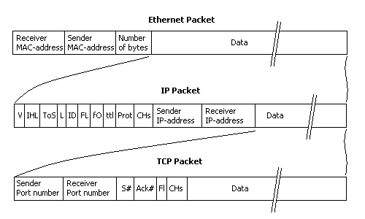

Figure 2.2.1a Packet encapsulation process

The whole network topology can be referred to Figure 2.2.1b. And the routes of packets are shown as the full line.

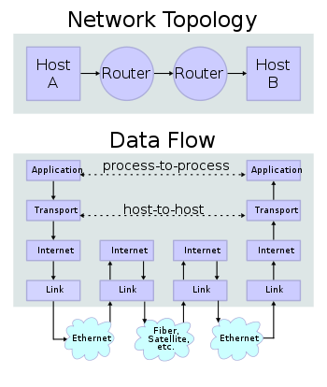

Figure 2.2.1b Routes of packets

### Inspection principle

The normal message inspection only analyses the contents of lower four layers, which contain the source IP address, destination IP address, the source IP port, destination IP port and the transmission protocol type. As for the application type, the normal message inspection can only identify it through the port number. However, the illegal application on network can hide or fake port number to avoid inspection and monitor, which resulted in an erosion of the network. Deep Packet Inspection was born for this. It can not only inspect the known protocol on non-standard port (HTTP message on non-80 port), but also non-standard protocol on a known port (data flow of Skype on 80 port). That means the traditional equation between port and application is no longer valid.

As a flow monitoring and control technique based on application layer, DPI has its unique operation sequence. When an IP data packet, a TCP or UDP data flow pass the bandwidth management system that based on DPI, the system can read the load content inside of IP packets in order to reorganize the application-layer information in the OSI model. Then it can proceed to the next step: obtaining the entire content of application programme and shaping the network traffic according to the definition of system management strategy.

### Three main recognition technology

#### Recognition based on “tagged word”

Different application protocols have their unique features: specific port, specific character string or specific bit sequence. According to the detection method, the recognition based on “tagged word” can be divided into fixed position matching, flexible position matching and state characteristic matching.

For example, the identification of Bit Torrent protocol follows this formula. There is a number that represent the length of the message before every message. When the network is handshaking, it send “19” first, followed by string “BitTorrent protocol”. Then “19BitTorrent protocol” become the “tagged word” of Bit Torrent.

#### Recognition at application layer gateway

The control flow and data flow of some protocols are separated. For these protocols, their data flow has no specific feature. Application layer gateway needs to recognize the control flow firstly, then analyse the control flow through a specific gateway based on its protocol, and finally recognize the corresponding data flow.

For each agreement, there need to be different application layer gateway to analyse it, such as SIP, H323 protocol. SIP/H323 negotiate its data tunnel through signalling interaction. The data flow is RTP format encapsulated voice flow. That is to say, the detection of RTP flow cannot obtain which kind of protocol this RTP flow was established on, unless by analysing the SIP/H323 protocol interaction.

#### Recognition based on behaviour pattern

This kind of recognition technique can judge the ongoing or forthcoming behaviour according to existing behaviour of consumer’s terminal. Recognition based on the behaviour pattern is usually used on those operations that cannot be identified through protocols.

For example, the data flows of spam email and normal email are same from the view of the network model. Only by analysing the user behaviour toward different email (white/black list), can the protocol and flow of spam email be identified.

## Advantage of using DPI on user behaviour analysis

The characteristic of reading into the load content of packet make DPI a possible way to obtain large amount of user behaviour information. Additionally, there is another advantage. If the network carrier use DPI, typically they can get much more comprehensive data than the network service company. Because the network carrier act as a tube and can look inside at every flow of data link as Figure 2.3a shows.

Service Company

Network

Carrier

Figure 2.3a

Additionally, the security of data and robustness of inspection system can be guaranteed due to the complex execution flow and multiple fault-tolerant principle of Deep Packet Inspection. Under the rigorous usage management from network carrier and government, the privacy of data would be largely protected.

# Design and Implementation

## nDPI platform deployment and testing

### Open source plans selection

Among many Deep Packet Inspection open source implementation plan, two plans were selected and compared: nDPI and Libprotoident. (See table 3.1a)

Table 3.1a

|  |  |  |  |
| --- | --- | --- | --- |
|  | Application protocols | Applications | Web services |
| nDPI | 15 out of 17 (ssl) | 17 out of 22 | Better performance |
| Libprotoident | 15 out of 17  (ssl, effective to encryption protocol) | 14 out of 22 | Normal performance because of only using first bytes |

nDPI scheme was chose due to its better performance. It is a library inherited from OpenDPI, maintained by NTOP company. nDPI was published under the permission of General Public License (GPL). Its goal is to increase the number of available protocols and extend the original library. Besides Unix, nDPI also support Windows and can be modified by developers in order to disable some unnecessary characteristics that caused a decline in the efficiency of DPI engine. In this way, nDPI is better for flow control applications. With the contribution of developers, nDPI now support 170 protocols and still exploring its limit.

### Deployment in a real network environment

To better inspect on the whole network state in the lab, the nDPI platform was deployed at the switch of the lab network, which control all the data flow through these links. For that most of the user behaviours could be exclusively recognized according to the protocol type in the Application layer, my research mainly focused on the HTML format of video websites.

The whole deployment architecture was showed as figure 3.1b. In this framework, different users are visiting different website to watch the videos through their devices in this network.



Figure 3.1b

## Real-time grasp the Internet packets and analyses the protocol type

### Execution flow

The platform analyses the data packet from the lower layer to the upper layer, which concludes the Data link layer, Network layer, Transport layer and Application layer. See figure 3.2.1a.



Figure 3.2.1a

Firstly, the platform will call the function “setupDetection()” to initialize programme. Then the system will assign a series of threads to call function “libpcap()” to circularly catch packets through the network card.

For each of the packets, the system will call function “pcap_packet_callback()” to unpack and analyze protocol in Data link layer and Network layer, judge whether it is based on IP or other protocols, and obtain source IP address, protocol type etc. This process can be displayed as a thread as figure 3.2.1b shows.



Figure 3.2.1b

After finishing the analysis in the first two layers, the platform will continually call function “packet_processing()” to unpack and analyze protocol in the Transport layer. In this layer, the system call function “get_ndpi_flow()”, which will return the structure: “ndpi_flow” with the transport layer information in it. Finally the system calculates “idx” (index of data flow) based on the five-elements set (source IP address, destination IP address, source port, destination port, protocol type( tcp/udp)). See Figure 3.2.1c.



Figure 3.2.1c

The programme will maintain an array that store all the data flow. Variable idx is used to identify those data flows. First the system will calculate the idx based on five-elements set and find whether there is a record on the position of idx of array “ndpi_flows_root[]”. Normally, when the first packet of a data flow try to query the array, it will return with null, then the system will make a new ndpi_flow object. When the system catch the next packets of this data flow and execute the query, it will directly return the existing ndpi_flow constructor, because they both belong to the same flow. The code segment below well demonstrates the function of “idx” variable and what “get_ndpi_flow” return.

|  |
| --- |
| idx = (vlan_id + lower_ip + upper_ip + iph->protocol + lower_port + upper_port) % NUM_ROOTS;  ret = ndpi_tfind(&flow,&ndpi_thread_info[thread_id].ndpi_flows_root[idx], node_cmp); |

Finally the system will call function “ndpi_detection_process_packet()” to analyze protocol in the Application layer, which is the most important function in protocol analysis. See figure 3.2.1d.



Figure 3.2.1d

The function “ndpi_detection_process_packet()” will firstly initialize the flow->packet constructor. Because, for the same data flow, some variables in the first packet of the flow have been initialized and will not change unless the system inspects a new protocol. However, for each of the data packets, the information in “flow->packet” constructor must be changed.

Then the system will call function “ndpi_connection_tracking()” to judge the position of this packet, for example, the three handshaking state of TCP connection establishment through the value of segments syn, ack, seq and ack_seq.

After that, the constructor “ndpi_selection_packet” will be set, which is used to store the information of lower four layers. This variable belongs to ndpi_selection_bitmask_protocol_size type, whose format is a series of binary bits such as 10101011. And each of the bits correspond to different meaning. The code segment below shows the functions of each bits.

|  |
| --- |
| #define NDPI_SELECTION_BITMASK_PROTOCOL_SIZE u_int32_t  #define NDPI_SELECTION_BITMASK_PROTOCOL_IP (1<<0)  #define NDPI_SELECTION_BITMASK_PROTOCOL_INT_TCP (1<<1)  #define NDPI_SELECTION_BITMASK_PROTOCOL_INT_UDP (1<<2)  #define NDPI_SELECTION_BITMASK_PROTOCOL_INT_TCP_OR_UDP (1<<3)  #define NDPI_SELECTION_BITMASK_PROTOCOL_HAS_PAYLOAD (1<<4)  #define NDPI_SELECTION_BITMASK_PROTOCOL_NO_TCP_RETRANSMISSION (1<<5)  #define NDPI_SELECTION_BITMASK_PROTOCOL_IPV6 (1<<6)  #define NDPI_SELECTION_BITMASK_PROTOCOL_IPV4_OR_IPV6 (1<<7)  #define NDPI_SELECTION_BITMASK_PROTOCOL_COMPLETE_TRAFFIC (1<<8) |

Finally, the system will call function “guessed_protocol_id” and “check _ndpi_flow_func()” to inspect the protocol type in the application layer. The packets will be distributed to different interfaces according to its protocol in the transport layer (TCP\UDP\neither). The system will judge the protocol type by circularly call the discrimination function until inspection successfully, or set to UNKNOWN. The whole execution flow of the inspection platform is finished. And the platform will return the statistical result of the packets in this pcap file, as figure 3.2.1e shows.

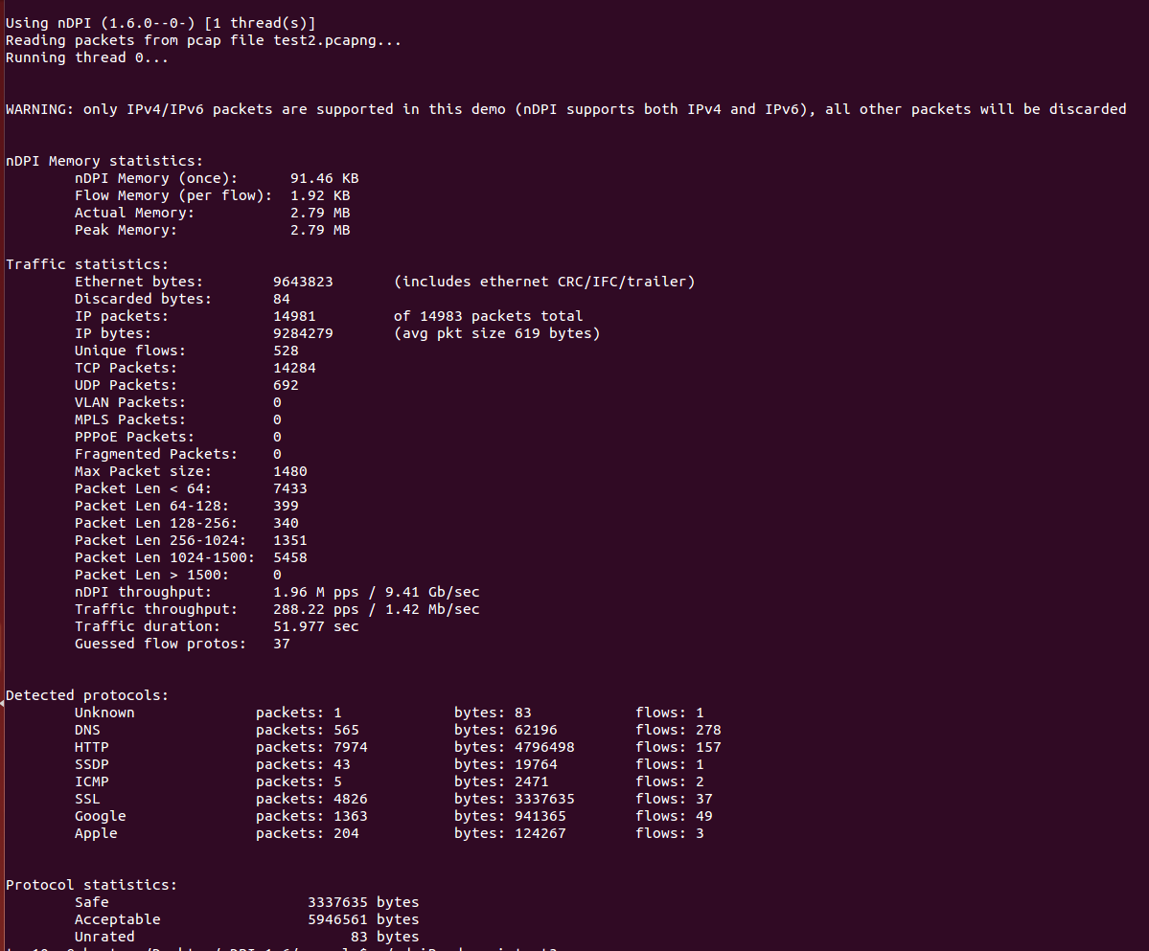

Figure 3.2.1e

### Regular expression summary

To accurately identify and extract the user behaviour information keyword, a survey was made on six dominating video website’s HTML code and its format was summarized into Regular Expression.

Regular expression (sometimes called rational expression) is a series of characters that define a search sequence pattern, it is mainly used for pattern string matching. This concept, "Find and replace" operation, appears in the 1950s, when American mathematician Stephen formalized description of regular language, and began to widespread use of Unix text processing tools, an editor, a grep and a filter.

For example, figure 3.2.2a shows the HTML code of Chinese biggest video website, Youku.

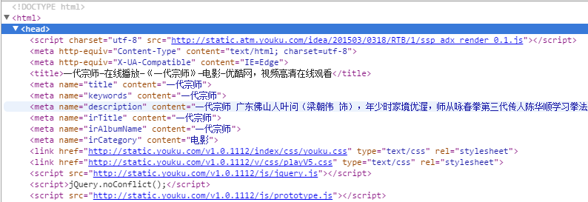

Figure 3.2.2a

In this HTML page, the main feature mainly concentrated in head part, the format of the header was summarized below:

|  |
| --- |
| HTML title:  <title>一代宗师—在线播放—《一代宗师》—电影—优酷网，视频高清在线观看</title>  Subtitle:  <meta name="title" content="一代宗师">  Keyword:  <meta name="keywords" content="一代宗师">  Story and feature:  <meta name="description" content="一代宗师 广东佛山人叶问（梁朝伟 饰），年少时家境优渥，师从咏春拳第三代传人陈华顺学习拳法，师傅“一条腰带一口气”的告诫，支持他走过兵荒马乱、朝代更迭的混乱年代。妻子张永...">  Subheading or episode name:  <meta name="irTitle" content="一代宗师">  Album name:  <meta name="irAlbumName" content="一代宗师">  Category(movie or TV series):  <meta name="irCategory" content="电影"> |

Then the regular expression that used to extract the user key word and title can be showed as the code below. The subsequent test showed this method with high sensitivity on the title of videos, which are, combined with the timestamps, the legible indicators of user habits.

|  |
| --- |
| Extract title：  <title>[\u4e00-\u9fa5]+—在线播放—《[\u4e00-\u9fa5]+》—[\u4e00-\u9fa5]+—优酷网，视频高清在线观看</title>  Extract subtitle or episode name:  "irTitle.*[\u4e00-\u9fa5]+ "  Extract album name:  "irAlbumName.*[\u4e00-\u9fa5]+"  Extract category:  "irCategory.*[\u4e00-\u9fa5]+" |

### Chunked packet encoding format in HTTP message and decompression implementation with C

This is a vital technological point in the implementation of the system. First we need to understand two concepts, data packet and data flow. A data flow may contain a lot of data packets. For example, when we request a webpage, the server will divide the information on the webpage into a number of packets because of the large amount of information. All these data packets belong to a same data flow.

When the client receives those packets, it should reorganize the packets and decompressed them. In this project, the system will use chunked block transmission format, in order to obtain the entire HTTP responding message content. Because we use Content-length to identify the length of the message for the normal HTTP message. However, for some webpage that cannot confirm the length of their message, the system must use chunked encoding format.

Chunk, just as its name implies, was a technique that blocks the large amount of information in to several smaller parts. See figure 3.2.3 a.

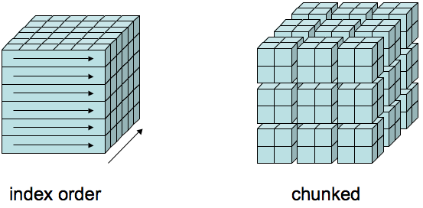

Figure 3.2.3 a.

Chunked encoding consist of several chunks strings and a 0-length chunk as the end mark. For the message that was compressed in gzip format, they were compressed firstly and chunked secondly. So at the client end, we need firstly reorganize the chunks and then decompressed the message as figure 3.2.3b shows.

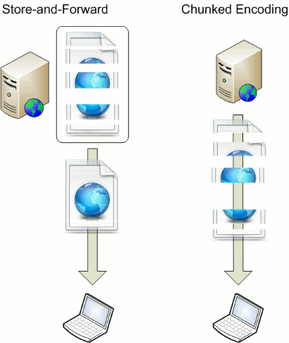

Figure 3.2.3 b.

For example, this a packet (figure 3.2.3c). The string “transfer-coding” in line3 and line4 indicates it is encoded in chunked format. In line5 “0d 0a 0d 0a” indicate this is the end of the header and will then be the content of the message. “32 35” is the size of the first chunk. In line10, “30 0d 0a 0d 0a” is the end of the chunk string because “30” shows that the current chunk’s size is zero.

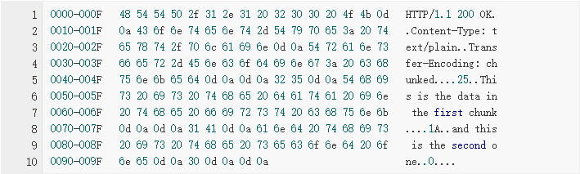

Figure 3.2.3 c.

The decompression programme obeys the principle above. It first judge whether the packet is the first one of the HTTP response, and then detect the size of the first chunk to reallocate a part of memory to initialize an array. The system circularly dechunk the packets from the socket until it detects the chunk who shows the current chunk’s size is zero.

However, there is a problem that this kind of operation will cause a big decline in efficiency due to the reallocation of memory. So I decide to use inflate() function in Zlib library to decompress HTTP message that was compressed through Gzip method. This method will directly decompress the message through memory, leaving out the reorganization step that chunked method use.

There is also a disadvantage of the Gzip method. By using Gzip, the correct message can be decompressed out, but only from a part of the whole webpage. Only by catching all the packets of this flow, can the whole page content be shown entirely. However, the subsequent test showed that the information of a video website page normally stored in the first packet. In this way, the platform can not only obtain the necessary information to describe this behaviour, but also save a large amount of efficiency.

## Programming realization of user behaviour analysis system

### MySQL storage

After catching and analysing the packets by nDPI system, the user behaviour related factors (source IP address, destination IP address, video title and timestamp) will be filtered in and stored into a MySQL database. See figure 3.3.1a.

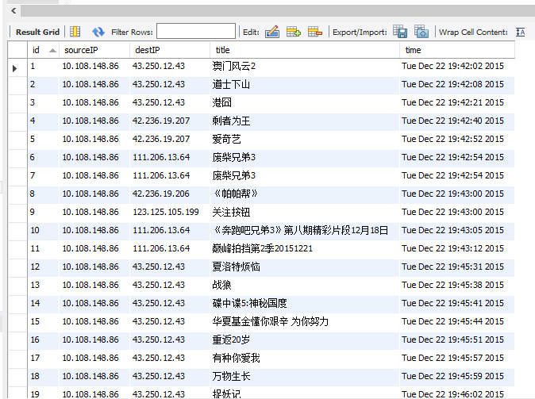

Figure 3.3.1 a.

A table “my_table” was created with five attributes. Every log means a data flow, and also, a webpage. “id” is used to identify every user log uniquely, which is the primary key of this table. “sourceIP” and “destIP” represent the device address of the client and website address of the server, which can be understood as the unique identifier of consumer and video website. “title” is the title of the video (Because the object of my research is Chinese people, most of the video title is in Chinese). “time” is the time when the data flow was transmitted, which means the access time of the user. The database was maintained at localhost and can be connected to the local server.

### Front-end query system

Finally, a primary analysis front-end platform was programmed for querying every user's access behaviour details and regional integrated situation. Webpage was selected as a tool of my front-end query system because of its dynamism and transparency. The front-end query system was deployed on Apache Tomcat8.0 and used Spring Framework, which is an application framework and inversion of control container for the Java platform. See figure 3.3.2a.

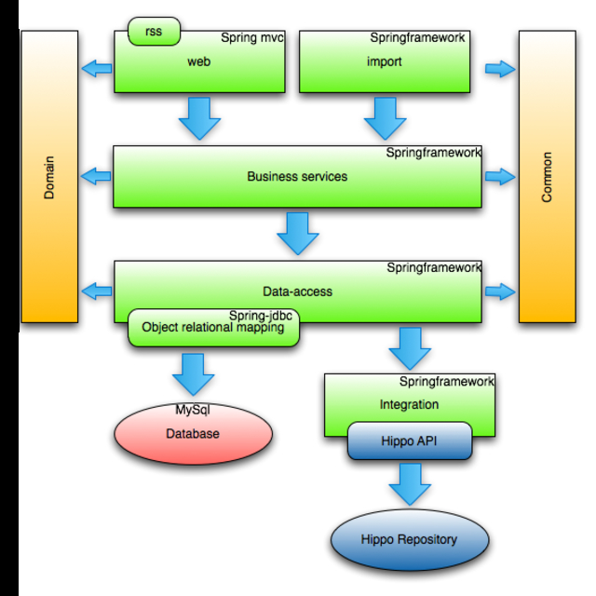

Figure 3.3.2a

By accessing the localhost IP address, the user can enter the user behaviour analysis system that based on DPI as figure 3.3.2b shows.

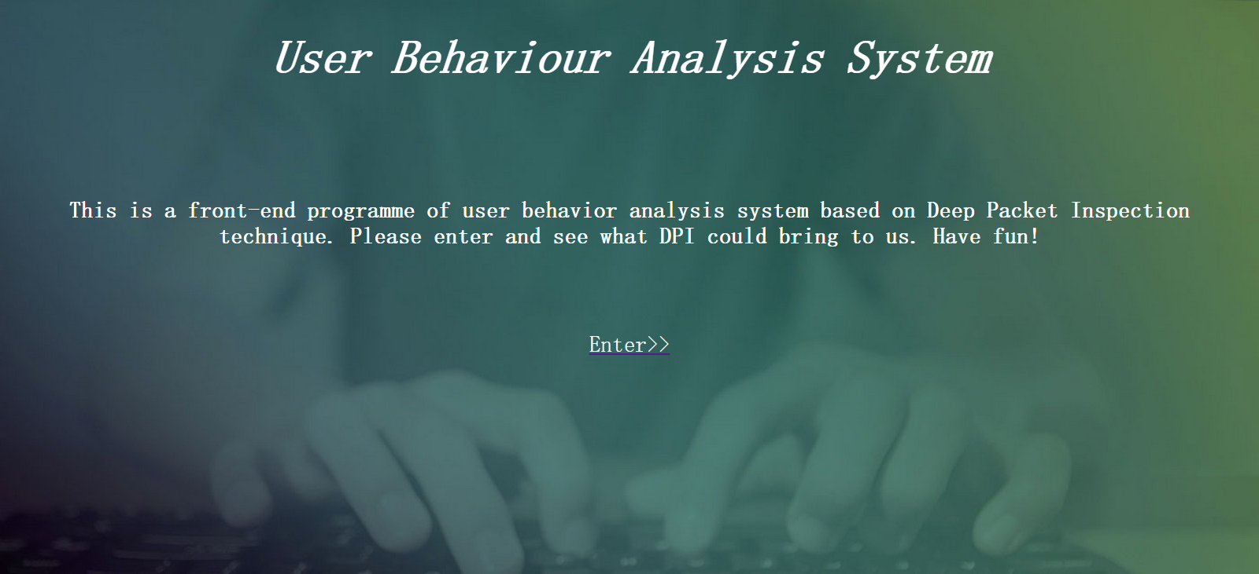

Figure 3.3.2b

The main page was divided into two parts. The upper part is used to let the user set any conditions while querying, which include the query method, log ID, source IP address, key word or phrase of video and time range. The two buttons under the conditions are used to submit the form and reset the form. As soon as the submit button was pressed, the system will make a query to the data base and return the result. The lower part is used to display the query result and the statistical number of eligible logs. The size of each page is set to 10 logs. See figure 3.3.2c.

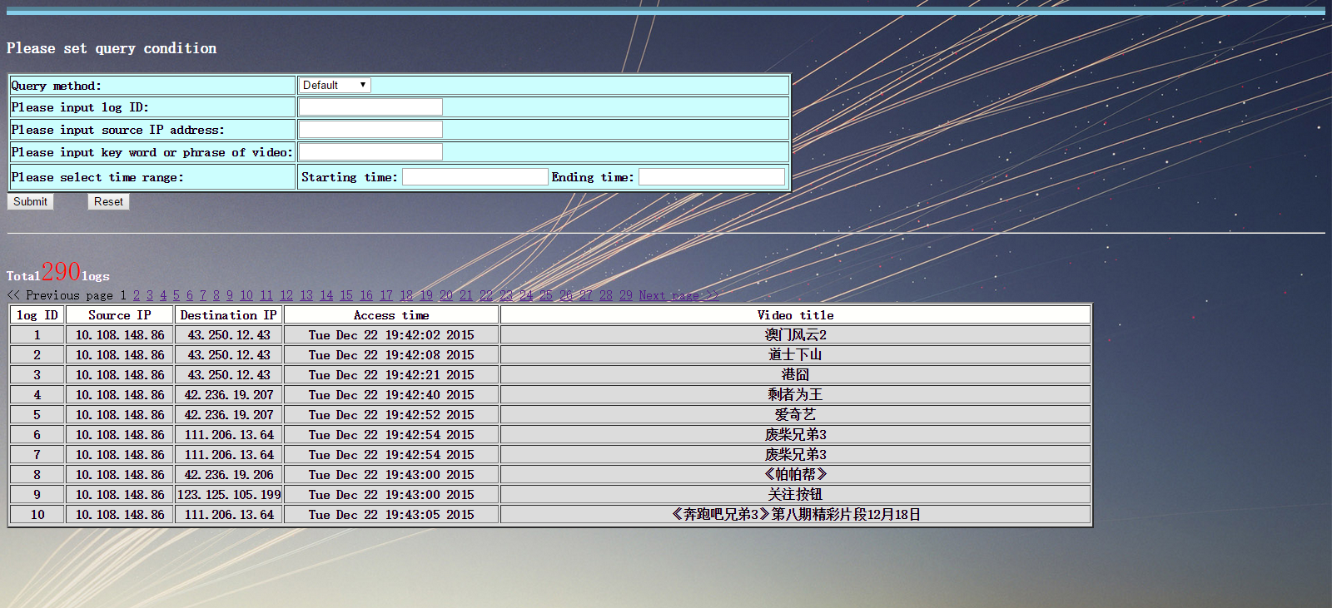

Figure 3.3.2c

The three query method of the platform are “Default”, “Find user” and “Find video”. The “Default” method will give a user the whole authority to change every condition and will return the entire information of each log. See figure 3.3.2d.

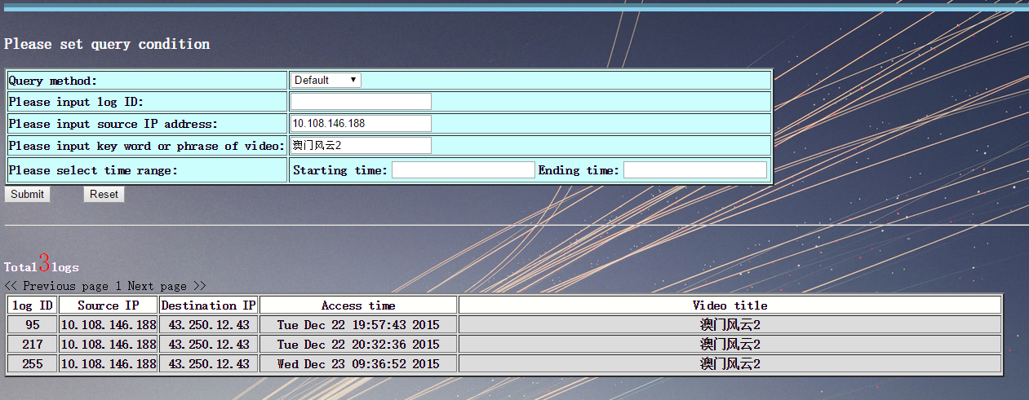

Figure 3.3.2d

In the “Find user” method, users are only allowed to set keyword of the video title and time range. The system will give the source IP address and statistical number of access times of every source IP. This method is used when the user wants to find who and how frequently the audience watch this video, which is “Find user” means. See figure 3.3.2e.

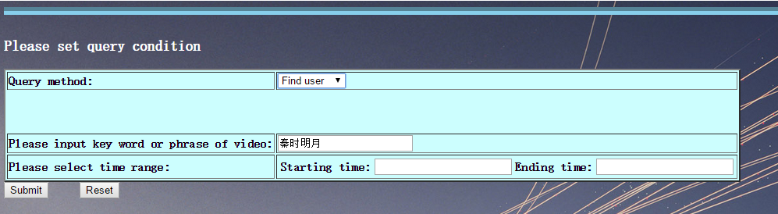

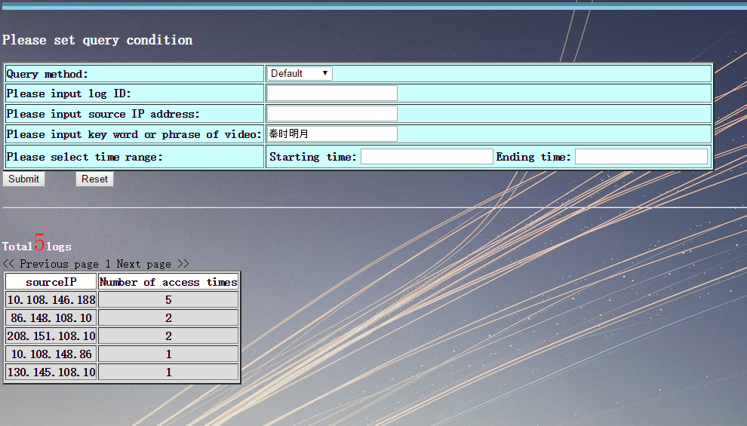

Figure 3.3.2 e

In the “Find video” method, users are only allowed to set the source IP address and time range. The system will give the title of videos and statistical number of access times for every video. This method is used when the user wants to find which video a specific audience like, which is “Find video” means. See figure 3.3.2 f.

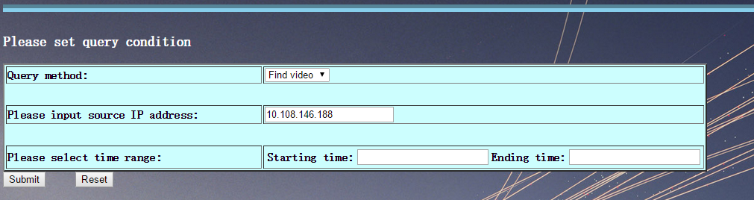

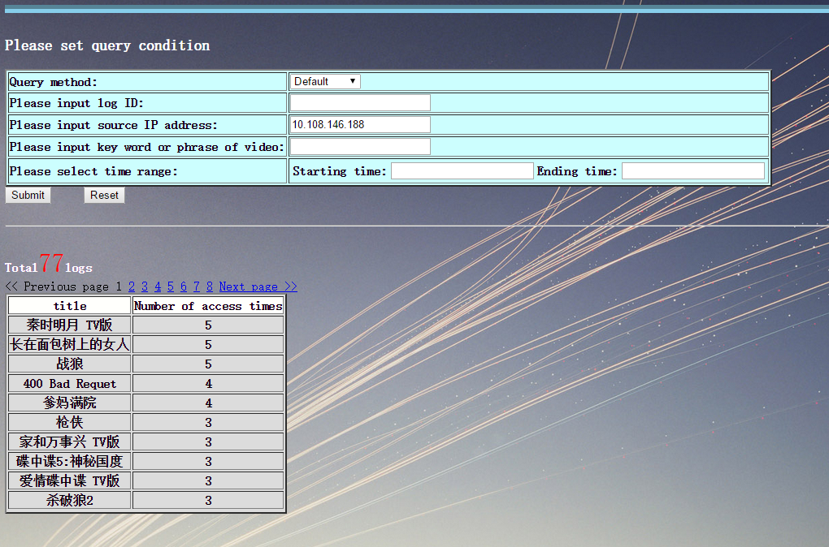

Figure 3.3.2 f

Every time when a query has been finished, the query method will be turned into default automatically for further use.

# Results and Discussion

The outputs of this project contained a nDPI platform on switch, a database and a front-end query system. The first two parts were developer-oriented and can be seen as a black box to the users. White/black box testing was conducted to ensure the robustness and accuracy of the system. Evaluation of the effectiveness and usability of the system were carried out. By comparing the results of the analytic system with the actual user behaviours and habits to verify the reliability, I get the conclusion of that the deep packet inspection will give the expected result and the prospect to be employed in more advanced user behaviour analysis.

For the user, we can divide them into several groups. The video websites and video authors may want to use “Find user” to know the audience of one specific video. They can know what kind of people like to watch this video and when they prefer to watch it, like news in the morning or TV series at night. Even more, when they directional assemble their expected audience, the video website can also analyse user behaviour and tastes through “Find video” with regard to each individuals. Those statistical data can be applied in many aspects as video promotion, accurate advertisements launching and intelligent video recommendation etc. For the network carrier, they can not only inspect the integrated regional network state, but also obtain the valuable user behaviour data. Those can be applied in their user-oriented network product development and more intelligent flow control programme, such as network video aggregation software and dynamic bandwidth distribution. From all consumers’ aspect, user behaviour analysis system based on DPI will be an unprecedented technique that may change our life.

# Conclusion and Further Work

This user behaviour analysis system showed a primary but unprecedented use of Deep Packet Inspection technology. People only use DPI on illegible packets inspection regional flow management in the past. Now I proved that with the help of DPI, the network carrier can collect their own user behaviour information, which can be applied in several aspects like accurate advertisement operation, recommendation based on user interests and habits. However, every technology is a double-edged sword. In the foreseeable future, the problem of privacy invasion and the user data security will be definitely raised. Only DPI technique was applied under the rigorous control by government or associations, can it be used legally and justly.

References

[1] Luft, S. J., & Chiang, P. (2010). *Network element architecture for deep packet inspection.* US, US 7719966 B2.

[2] Kumar, S., Dharmapurikar, S., Yu, F., Crowley, P., & Turner, J. (2006). *Algorithms to accelerate multiple regular expressions matching for deep packet inspection.* Acm Sigcomm Computer Communication Review,36(4), 339-350.

[3] *“nDPI execution flow”* <http://blog.csdn.net/liuchonge/article/details/50118943>

[4] Alsbih, A., Janson, T., & Schindelhauer, C. (2011). *Analysis of Peer-to-Peer Traffic and User Behaviour.* International Conference on Internet Technologies & Applications.

[5] Nagy, I. K., & Gasparpapanek, C. (2008). *User behaviour analysis based on time spent on web pages.* Web Mining Applications in E-commerce and E-services, 117-136.

[6] Swaminathan, V., & Wei, S. (2011). *Low latency live video streaming using HTTP chunked encoding.* IEEE, International Workshop on Multimedia Signal Processing (pp.1-6).

[7] 孙卫琴. (2004). *Tomcat与Java Web开发技术详解.* 电子工业出版社.

[8] Johnson, R., Hoeller, J., Arendsen, A., Risberg, T., & Kopylenko, D. (2006). *Professional java development with the spring framework.* Apc, 195-237.

[9] Lin, P. C., Lin, Y. D., Lai, Y. C., & Lee, T. H. (2008). *Using string matching for deep packet inspection.* Computer, 41(4), 23-28.

[10] Collins, R. T. G. (2009). *Privacy implications of deep packet inspection technology: why the next wave in online advertising shouldn't rock the self-regulatory boat,* the. Ga.l.rev.

Acknowledgement

Thanks to my supervisors Pro.Yao and Dr. Fang. They inspire me on my idea of this project. Thanks to my mentors Danyang and Chong. You are the best teachers and friends during my final project. You help me with the deployment of DPI system and help me to fix the technical difficulties I met when I first learn the source code. It is a great honour to work with you. Finally, thanks to my parents and all my friends. It is you who always encourage me during my four-year undergraduate life. Thank you with all my heart!

Risk Assessment

This project aims develop a user behaviour analysis system based on Deep Packet Inspection. After the deployment of nDPI system on the switch board of our lab, I real-time grasped the packets from Internet and filtered and stored user behaviour-related factors into a MySQL database. Then I implement a front-end query system to show the result. There are some factors that may have an impact on the achievement of this project, which I will list below.

Table 1

|  |  |  |  |  |
| --- | --- | --- | --- | --- |
| Description of Risk | Description of Impact | Likelihood Rating | Impact Rating | Preventative Actions |
| Information stored in second or further packet | Have to reorganize the packets into flow, which decline efficiency | Likely | Serious | Filter those flows and reorganized the packets with Chunked method |
| System crash | Discontinuity in recording the user behaviour data | Unlikely | Major | Back up the system on another switch and start it when emergency |
| Server crash | User cannot visit the front-end website | Moderate | Major | Automatically restart the server when crash |
| Data flooding | Decline the efficiency of data processing | Likely | Serious | Deploy on distributed system to process the data |
| DDOS attack | Effective approaches will be hidden in fake approaches | Rare | Serious | Use safe and static website back-end security solution |
| SQL injection | Error in query actions | Rare | Serious | Check user’s each inputs with regular expression |

Environmental Impact Assessment

The only one impact of this project is about privacy invasion resulted from the use of log data. This problem also exists in other industries that use the user behaviour analysis techniques. With my perspective, there are three principles the user of this product must obey. First, the ownership of all the collected data must belong to the user themselves, instead of the companies. The ownership of data should be protected just as the ownership of property. Second, the companies who use the data to provide information service should store and transport the data in security, which is the responsibility of the enterprise. Third, the companies must give the user the right to know and choose whether they want their data be used prior to any operations. Every technique is a double edged sword, only it was applied under the rigorous control by government or associations, can it be used legally and justly.